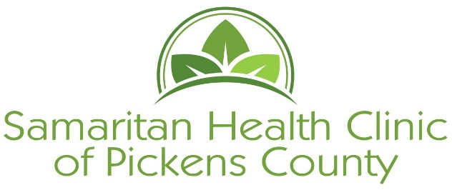
864-855-0853
303 Dacusville Hwy, Easley, SC 29640

Clinic Requirements for New and Renewing Patients
- Patient must not be on any Health insurance plans, including private, Medicaid or Medicare.
- Provide proof of residency in Pickens County. The proof must include the patient’s name. Documents that we accept:
-SC Driver’s License or SC Identification card
- Utility Bill (Water, Electric, Gas, Phone, Cable)
- Lease agreement
Documents must have patient’s name on bill or name of person listed as living in household.
- Proof of income for every person living in the home. Documents that we accept:
- Pay stubs for the last month (if paid weekly bring 4, if
paid every two weeks bring 2)
- Signed Self Declaration form to be filled out by employer when pay stubs
are not available. SHC will provide the Self Declaration form
- Disability Award letter for the current year
- Social Security Award letter for the current year
- Child support documentation
- Social Security Card
- Photo ID
- Food Stamp statement call DSS (864)898-5810 and request the statement to be faxed to SHC fax 864- 855-5882
Interviews are Mondays, Wednesdays, and Thursdays between 9am and 12 noon. You must be here by 11:30 to complete the interview before noon.
Patients must interview once a year to remain an active patient.

